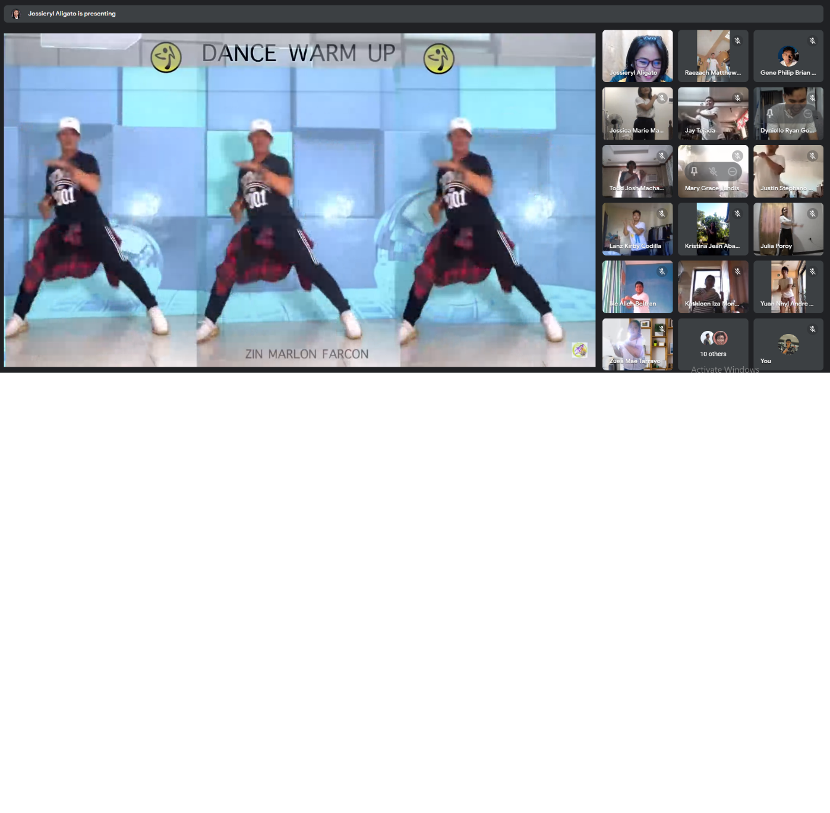

REFLECTION

I enjoyed doing the zumba exercise together with all my classmates. It is honestly better to do it with others rather than just alone like the first instance of the zumba activity. Even if I just woke up before the class, the zumba exercise was energizing and woke up me to be prepared for the rest of the day.

I was off cam during the zumba exercise only because my brother was also inside the room changing for work. Aside from that, I participated as expected and I even did the closing prayer. 😊